Owner’s Manual & Safety Instructions

|  |  |
| --- | --- |
| Save This Manual Keep this manual for the safety warnings and precautions, assembly, |  |
| operating, inspection, maintenance and cleaning procedures. Write the product’s serial number in the |  |
| back of the manual near the assembly diagram (or month and year of purchase if product has no number). |  |
| Keep this manual and the receipt in a safe and dry place for future reference. | 22j |

**Visit our website at: http://www.harborfreight.com**

**Email our technical support at: productsupport@harborfreight.com**

When unpacking, make sure that the product is intact and undamaged. If any parts are missing or broken, please call 1-888-866-5797 as soon as possible.

Copyright© 2022 by Harbor Freight Tools®. All rights reserved.

No portion of this manual or any artwork contained herein may be reproduced in any shape or form without the express written consent of Harbor Freight Tools. Diagrams within this manual may not be drawn proportionally. Due to continuing improvements, actual product may differ slightly from the product described herein.

Tools required for assembly and service may not be included.

Read this material before using this product.

Failure to do so can result in serious injury.

SAVE THIS MANUAL.

|  |
| --- |
| **tyfeSa** |

|  |
| --- |
| **etupS** |

|  |
| --- |
| **eratiOp** |

|  |
| --- |
| **e nanc** |

**Table of Contents**

|  |  |  |  |
| --- | --- | --- | --- |
| Safety.......................................................... | 2 | Maintenance............................................... | 11 |
| Specifications.............................................. | 6 | Parts List and Diagram............................... | 14 |
| Setup........................................................... | 6 | Warranty..................................................... | 16 |
| Operation.................................................... | 8 |  |  |



**WARNING SYMBOLS AND DEFINITIONS**

This is the safety alert symbol. It is used to alert you to potential



personal injury hazards. Obey all safety messages that

follow this symbol to avoid possible injury or death.

Indicates a hazardous situation which, if not avoided,



will result in death or serious injury.

Indicates a hazardous situation which, if not avoided,



could result in death or serious injury.

Indicates a hazardous situation which, if not avoided,



could result in minor or moderate injury.



Addresses practices not related to personal injury.



**IMPORTANT SAFETY INFORMATION**

**General Tool Safety Warnings**



**Read all safety warnings and instructions.**

*Failure to follow the warnings and instructions may result in electric shock, fire and/or serious injury.*

**Save all warnings and instructions for future reference.**

|  |
| --- |
| **Maint** |

1. KEEP GUARDS IN PLACE and in working order.
2. REMOVE ADJUSTING KEYS AND WRENCHES. Form habit of checking to see that keys and adjusting wrenches are removed from tool before turning it on.
3. KEEP WORK AREA CLEAN.

Cluttered areas and benches invite accidents.

1. DON’T USE IN DANGEROUS ENVIRONMENT. Don’t use power tools in damp or wet locations,

or expose them to rain. Keep work area well lighted.

1. KEEP CHILDREN AWAY. All visitors should be kept safe distance from work area.
2. MAKE WORKSHOP KID PROOF with padlocks, master switches, or by removing starter keys.
3. DON’T FORCE TOOL. It will do the job better and safer at the rate for which it was designed.
4. USE RIGHT TOOL. Don’t force tool or attachment to do a job for which it was not designed.

Page 2 **For technical questions, please call 1-888-866-5797.** Item 57286

**Table A: RECOMMENDED MINIMUM WIRE GAUGE FOR EXTENSION CORDS (120 VOLT)**

|  |  |  |  |  |
| --- | --- | --- | --- | --- |
| **NAMEPLATE** | **EXTENSION CORD** | | | |
| **AMPERES** |  | **LENGTH** | |  |
| **(at full load)** | **25′** | **50′** | **100′** | **150′** |
| 0 – 6 | 18 | 16 | 16 | 14 |
| 6.1 – 10 | 18 | 16 | 14 | 12 |
| 10.1 – 12 | 16 | 16 | 14 | 12 |
| 12.1 – 16 | 14 | 12 | **Do not use.** | |

1. USE PROPER EXTENSION CORD. Make sure your extension cord is in good condition. When using

an extension cord, be sure to use one heavy enough to carry the current your product will draw. An undersized cord will cause a drop in line voltage resulting in loss of power and overheating.

Table A shows the correct size to use depending on cord length and nameplate ampere rating.

If in doubt, use the next heavier gauge.

The smaller the gauge number, the heavier the cord.

1. WEAR PROPER APPAREL. Do not wear

loose clothing, gloves, neckties, rings, bracelets, or other jewelry which may get caught in moving parts. Nonslip footwear is recommended.

Wear protective hair covering to contain long hair.

1. ALWAYS USE SAFETY GLASSES. Also use face or dust mask if cutting operation is dusty. Everyday eyeglasses only have impact resistant lenses, they are NOT safety glasses.
2. SECURE WORK. Use clamps or a vise to

hold work when practical. It’s safer than using your hand and it frees both hands to operate tool.

1. DON’T OVERREACH.

Keep proper footing and balance at all times.

1. MAINTAIN TOOLS WITH CARE. Keep tools sharp and clean for best and safest performance. Follow instructions for lubricating and changing accessories.
2. DISCONNECT TOOLS before servicing; when changing accessories, such as blades, bits, cutters, and the like.
3. REDUCE THE RISK OF UNINTENTIONAL STARTING. Make sure switch is in

off position before plugging in.

1. USE RECOMMENDED ACCESSORIES. Consult the owner’s manual for recommended accessories. The use of improper accessories may cause risk of injury to persons.
2. NEVER STAND ON TOOL.

Serious injury could occur if the tool is tipped or if the cutting tool is unintentionally contacted.

1. CHECK DAMAGED PARTS. Before further use of the tool, a guard or other part that is damaged should be carefully checked to determine that

it will operate properly and perform its intended function – check for alignment of moving parts, binding of moving parts, breakage of parts, mounting, and any other conditions that may affect its operation. A guard or other part that is damaged should be properly repaired or replaced.

1. DIRECTION OF FEED.

Feed work into a blade or cutter against the direction of rotation of the blade or cutter only.

1. NEVER LEAVE TOOL RUNNING UNATTENDED. TURN POWER OFF. Don’t leave tool

until it comes to a complete stop.

|  |
| --- |
| **Safety** |

|  |
| --- |
| **Setup** |

|  |
| --- |
| **Operation** |

|  |
| --- |
| **Maintenance** |

Item 57286 **For technical questions, please call 1-888-866-5797.** Page 3

|  |
| --- |
| **tyfeSa** |

**Grounding Instructions**



**TO PREVENT ELECTRIC SHOCK AND DEATH FROM INCORRECT**

**GROUNDING WIRE CONNECTION READ AND FOLLOW THESE INSTRUCTIONS:**

**110-120 VAC Grounded Tools: Tools with Three Prong Plugs**

|  |
| --- |
| **etupS** |

|  |
| --- |
| **eratiOp** |

|  |
| --- |
| **e nanc Maint** |

1. In the event of a malfunction or breakdown, grounding provides a path of least resistance for electric current to reduce the risk of electric shock. This tool is equipped with an electric cord having an equipment-grounding conductor and a grounding plug. The plug must be plugged into a matching outlet that is properly installed and grounded in accordance with all local codes and ordinances.
2. Do not modify the plug provided – if it will not fit the outlet, have the proper outlet installed by a qualified electrician.
3. Improper connection of the equipment-grounding conductor can result in a risk of electric shock. The conductor with insulation having an outer surface that is green with or without yellow stripes is the equipment-grounding conductor.

If repair or replacement of the electric cord or plug is necessary, do not connect the equipment-grounding conductor to a live terminal.

1. Check with a qualified electrician or service personnel if the grounding instructions are not completely understood, or if in doubt as to whether the tool is properly grounded.
2. Use only 3-wire extension cords that have 3-prong grounding plugs and 3-pole receptacles that accept the tool’s plug.
3. Repair or replace damaged or worn cord immediately.

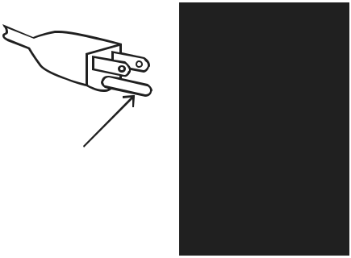

**Grounding**

**Pin**

**125 VAC 3-Prong Plug and Outlet (for up to 125 VAC and up to 15 A)**

1. This tool is intended for use on a circuit that has an outlet that looks like the one illustrated above in **125 VAC 3-Prong Plug and Outlet**. The tool hasa grounding plug that looks like the plug illustrated above in **125 VAC 3-Prong Plug and Outlet**.
2. The outlet must be properly installed and grounded in accordance with all codes and ordinances.
3. Do not use an adapter to connect this tool to a different outlet.

Page 4 **For technical questions, please call 1-888-866-5797.** Item 57286

**Grinder Tool Safety Warnings**

**For Your Own Safety Read Instruction**

**Manual Before Operating Tool Grinder**

1. Wear eye protection.
2. Use grinding wheel suitable for speed of grinder.
3. Replace cracked wheel immediately.
4. Always use guards and eye shields.
5. Do not overtighten wheel nut.
6. Use only flanges furnished with the grinder.
7. Adjust distance between wheel and work rest to maintain 0.125 inch or less separation as the diameter of the wheel decreases with use.
8. Frequently clean grinding dust from beneath grinder.
9. Wear a full face shield over ANSI‑approved safety goggles during use.
10. Do not grind with side of wheel unless wheel is specifically designed for that type of grinding.
11. **DO NOT OPERATE WITH ANY GUARD DISABLED, DAMAGED, OR REMOVED. Moving guards must move freely and close instantly.**
12. The use of accessories or attachments not recommended by the manufacturer may result in a risk of injury to persons.
13. When servicing use only identical replacement parts.
14. Do not depress the spindle lock when starting or during operation.
15. Only use safety equipment that has been approved by an appropriate standards agency. Unapproved safety equipment may not provide adequate protection. Eye protection must be ANSI-approved and breathing protection must be NIOSH-approved for the specific hazards in the work area.
16. Stay alert, watch what you are doing and use common sense when operating a power tool. Do not use a power tool while you are tired or under the influence of drugs, alcohol or medication. A moment of inattention while operating power tools may result in serious personal injury.
17. Industrial applications must follow OSHA guidelines.
18. Maintain labels and nameplates on the tool. These carry important safety information.

If unreadable or missing, contact Harbor Freight Tools for a replacement.

1. Avoid unintentional starting.

Prepare to begin work before turning on the tool.

1. People with pacemakers should consult their physician(s) before use. Electromagnetic fields in close proximity to heart pacemaker could cause pacemaker interference or pacemaker failure.
2. The warnings, precautions, and instructions discussed in this instruction manual cannot cover all possible conditions and situations that may occur. It must be understood by the operator that common sense and caution are factors

which cannot be built into this product, but must be supplied by the operator.

|  |
| --- |
| **Safety** |

|  |
| --- |
| **Setup** |

**Vibration Safety**

This tool vibrates during use. Repeated or long-term exposure to vibration may cause temporary or permanent physical injury, particularly to the hands, arms and shoulders. To reduce the risk of vibration-related injury:

1. Anyone using vibrating tools regularly or for an extended period should first be examined by a doctor and then have regular medical check‑ups to ensure medical problems are not being caused or worsened from use. Pregnant women or people who have impaired blood circulation to the hand, past hand injuries, nervous system disorders, diabetes, or Raynaud’s Disease should not use this tool. If you feel any medical or physical symptoms related to vibration (such as tingling, numbness, and white or blue fingers), seek medical advice as soon as possible.
2. Do not smoke during use. Nicotine reduces the blood supply to the hands and fingers, increasing the risk of vibration-related injury.
3. Use tools with the lowest vibration when there is a choice between different processes.
4. Include vibration-free periods each day of work.
5. Grip workpiece as lightly as possible (while still keeping safe control of it). Let the tool do the work.
6. To reduce vibration, maintain the tool as explained in this manual. If any abnormal vibration occurs, stop use immediately.

|  |
| --- |
| **Operation** |

|  |
| --- |
| **Maintenance** |

 **SAVE THESE INSTRUCTIONS.**

Item 57286 **For technical questions, please call 1-888-866-5797.** Page 5

|  |
| --- |
| **tyfeSa** |

|  |
| --- |
| **etupS** |

**Specifications**

|  |  |
| --- | --- |
| Electrical Rating | 120VAC / 60Hz / 2.1A |
|  |  |
| Motor No Load Speed | 3,450 RPM |
|  |  |
| Max. Accessory Diameter | 6″ |
| Arbor Size | 1/2″ |

**Setup - Before Use:**



**Read the ENTIRE IMPORTANT SAFETY INFORMATION section at the beginning of this manual including all text under subheadings therein before set up or use of this product.**



**TO PREVENT SERIOUS INJURY FROM ACCIDENTAL OPERATION:**

**Turn the Power Switch of the tool off and unplug the tool from its electrical outlet before performing any procedure in this section.**

**Note:** For additional information regarding the parts listed in the following pages, refer to the Assembly Diagram near the end of this manual.

**Assembly/Mounting**

|  |
| --- |
| **eratiOp** |

The two mounting holes in the Base can be used to attach this Grinder to a stable workbench using appropriate hardware (sold separately).

1. Attach Right Work Rest (36) to the Right Inner Wheel Guard (35). Use Work Rest Lock Knob (11) and Bolt (15) to secure it in place. See below.

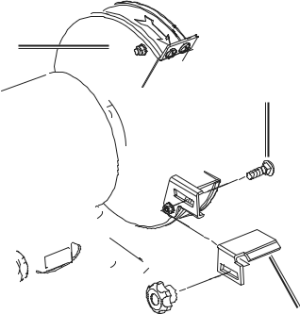

**Inner Wheel**

**Guard (35)**

**Bolt (15)**

1. Attach an LED light (7) to each Inner

Wheel Guard (14,35) using two Screws, Spring Washers, Flat Washers (1) on each side. See below.

**LED Light (7)**

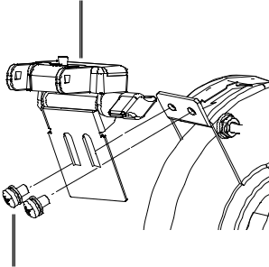

|  |
| --- |
| **e nanc** |

**Work**

**Rest (36)**

**Lock Knob (11)**

**Screw (1)**

1. Attach an Eye Shield (5) to each Light using an Eye Shield Lock Nut (4) and Hex Bolt (8) on each side. See below.

**Eye**

**Shield (5)**

|  |
| --- |
| **Maint** |

1. Attach Left Work Rest (12) to the Left Inner Wheel Guard (14). Use Work Rest Lock Knob (11) and Bolt (15) to secure it in place.
2. Adjust the Work Rests to within 1/16″ of the Grinding Wheel. To adjust this distance, loosen Bolts (15) and move Work Rests (36/12).

**Lock**

**Nut (4)**

**Hex**

**Bolt (8)**



Page 6 **For technical questions, please call 1-888-866-5797.** Item 57286

**Functions**

**LED Power**

**Button**

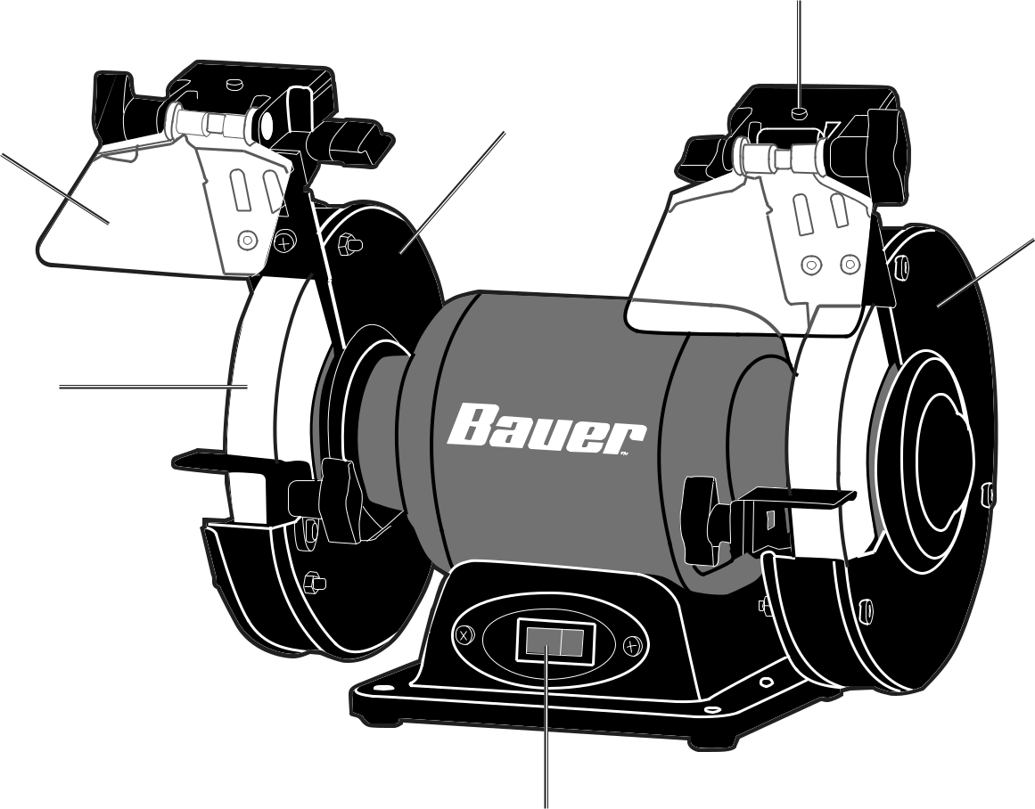

**Inner Wheel**

**Eye**  **Guard**

**Shield**

**Grinding**

**Wheel**

**Work Rest** 

**Power Switch**

Item 57286 **For technical questions, please call 1-888-866-5797.**

|  |
| --- |
| **Safety** |

**Wheel**

**Cover**

|  |
| --- |
| **Setup** |

|  |
| --- |
| **Operation** |

|  |
| --- |
| **Maintenance** |

Page 7

|  |
| --- |
| **tyfeSa** |

**Operating Instructions**



**Read the ENTIRE IMPORTANT SAFETY INFORMATION section at the beginning of this manual including all text under subheadings therein before set up or use of this product.**

**Tool Set Up**



**TO PREVENT SERIOUS INJURY FROM ACCIDENTAL OPERATION:**

**Turn the Power Switch of the tool off and unplug the tool from its electrical outlet before performing any procedure in this section.**

**TO PREVENT SERIOUS INJURY:**

**DO NOT OPERATE WITH ANY GUARD DISABLED, DAMAGED, OR REMOVED.**

**Moving guards must move freely and close instantly.**

**Replacing a Grinding Wheel**

|  |
| --- |
| **etupS** |

|  |
| --- |
| **eratiOp** |

|  |
| --- |
| **e nanc Maint** |

1. The Grinding Wheel MUST be:
   * + rated to at least 3,450 RPM.
     + no larger than 6″ (152.4 mm) in diameter.
     + fitted with a 1/2″ round arbor hole.
     + 3/4″ thick.
     + suitable for edge grinding, not surface grinding.
     + dry and clean.
     + proven undamaged by inspection and by the ring-test explained below.
2. Loosen each Eye Shield Lock Nut and move both Eye Shields up to access the Work Rests.
3. Remove both Work Rests.
4. Remove the Screws (21) holding Wheel Covers (20, 33) to the Bench Grinder.
5. Remove Wheel Covers.
6. Place a small wooden wedge between the Grinding Wheel and Work Rest to prevent Wheel from rotating.
7. Remove the right side Grinding Wheel (34) by turning the Nut (32) counterclockwise with a wrench (not included).
8. Remove the left side Grinding Wheel (18) by turning the Nut (19) clockwise with a wrench (not included).
9. Remove the Outer Flange (17) and remove Grinding Wheel. Keep the Inner Flange in position on the Spindle.
10. Closely inspect the wheel before mounting. Perform a ring-test on the wheel (unless wheel is smaller than 4″ or is an unusual shape) as follows:
    1. Suspend wheel using a dowel or finger through the arbor hole.

|  |  |  |  |
| --- | --- | --- | --- |
| **Hang** | **45°** | **45°** |  |
|  | **V** |  |
| **Wheel** |  |  |
|  | **E** |  |
| **from** |  | **R** |  |
|  | **T** |  |
| **Dowel** |  | **I** |  |
|  |  | **C** |  |
|  |  | **A** |  |
|  |  | **L** |  |
| **Tap** |  |  |  |
| **Wheel** |  |  |  |
| **Here** |  | **C** |  |
|  |  | **E** |  |
|  |  | **N** |  |
|  |  | **T** |  |
|  |  | **E** |  |
|  |  | **R** |  |
|  | **45°** | **45°** |  |

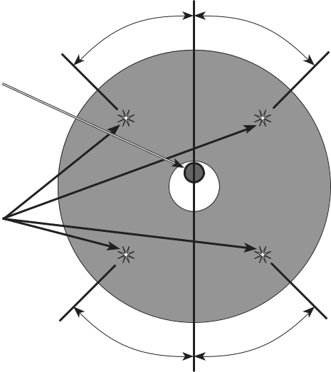

* 1. Tap the flat side of the wheel with a light non‑metallic object, such as a screwdriver handle, at a point 45° from the vertical center line on each side of the wheel and 1 – 2 inches from the edge of the wheel (see Illustration).
  2. Rotate the wheel and repeat the test until the entire wheel has been checked.
  3. An undamaged wheel will

give a clear tone. If cracked, there will be a dead sound and not a clear ring.

1. For wheels with paper gaskets (blotters) or metal gaskets: Slip the grinding wheel onto the Spindle with the gasket first. The gasket should be centered on the grinding wheel and the wheel and gasket should rest flat against the Inner Flange.

**WARNING: To prevent serious injury, gaskets must be used for all grinding wheels they are provided with. Gaskets help prevent grinding wheel damage and wheel slippage,**

**causes of wheel failure.**

Page 8 **For technical questions, please call 1-888-866-5797.** Item 57286

1. Thread the Outer Flange onto the Spindle. Wrench tighten only enough so that the wheel is securely held on the spindle.

**WARNING: To prevent serious injury,**

**do not overtighten flange. Overtightening can damage the wheel, causing wheel failure.**

**Operating LED Lights**

|  |  |  |  |  |
| --- | --- | --- | --- | --- |
| 1. | To operate LED lights, insert two AAA | **NOTICE:** Do not mix old and new batteries. Do not | |  |
|  | batteries into the battery compartment. |  |  |  |
|  | mix alkaline, standard (carbon-zinc), or rechargeable | |  |
| 2. | Close battery compartment and | (nickel-cadmium) batteries. Position batteries in proper | |  |
| polarity. Do not use swollen or leaking batteries. | |  |
|  | press LED power button. |  |  |  |

**Correcting Wheel Balance**

|  |
| --- |
| **Safety** |

Confirm Wheel balance by spinning the Wheel by hand and observing the Wheel distance from the Tool Rest as it spins; variations in this distance indicates the Wheel balance needs to be corrected:

1. Loosen Nut, and manually (if possible) adjust the Wheel closer to the Arbor centerline; hold in place while tightening the Nut.
2. Use a Wheel Dresser to remove the outermost layer and / or high spots of the Grinding Wheel to achieve Wheel balance. Follow the Wheel Dresser Manufacturer’s instructions.

**Note:** If Wheel still vibrates excessively after the Wheel has been dressed or adjusted to center as described above, and Wheel does not exhibit wobble from side to side at speed, Wheel is likely out of balance and should be replaced.

|  |
| --- |
| **Setup** |

**Eliminating Wheel Wobble (Side to Side)**

**Note:** Slight side to side wobble may exist as the Wheel spins up or down from full speed, but this will not affect normal operation. Follow the instructions below to remove excessive side to side wobble:

1. Loosen Nut and rotate Outer Flange slightly. Snug the Nut and rotate the Wheel by hand to confirm wobble is eliminated.
2. If Wobble still exists, continue repeating step 1 in slight increments in the same direction, making sure Wheel is in the same orientation as it was in step 1.
3. If Wobble is still not eliminated, continue holding Wheel in same orientation as it was in step

1, and rotate Inner Flange 90o. Repeat Steps

1-2. Continue this sequence of Inner and Outer Flange movements until Wobble is eliminated.

**Note:** If necessary, a shim made of paper / card stock may be placed between the Inner or Outer Flange and Wheel. If excessive Wobble still exists, consult ″Troubleshooting″ on page 12, remembering these possible sources of imbalance:

* Wheel is not balanced or is out-of-round.
* Wheel Arbor bushing has excessive play.
* Wheel is of poor quality.
* Inner or Outer Flanges are warped.

|  |
| --- |
| **Operation** |

|  |
| --- |
| **Maintenance** |

Item 57286 **For technical questions, please call 1-888-866-5797.** Page 9

**Workpiece and Work Area Set Up**

|  |
| --- |
| **tyfeSa** |

1. Designate a work area that is clean and well lit. The work area must not allow access by children or pets to prevent distraction and injury.
2. Route the power cord along a safe route to reach the work area without creating a tripping hazard or exposing the power cord to possible damage. The power cord must reach the work area with enough extra length to allow free movement while working.
3. There must not be objects, such as utility lines, nearby that will present a hazard while working.
4. You must use personal safety equipment including, but not limited to, ANSI-approved eye and hearing protection, as well as heavy-duty work gloves.
5. Before beginning work, provide for sparks and debris that will fly off the work surface.

**General Operating Instructions**

|  |
| --- |
| **etupS** |

|  |
| --- |
| **eratiOp** |

|  |
| --- |
| **e nanc Maint** |

1. Make sure that the Switch is in the off‑position, then plug in the tool.
2. Adjust the spark arrestor and the work rest frequently so as to compensate for wear of the wheel.
3. Keep the distance between the spark arrestor/ work rest and the wheel as small as possible and in any case not greater than 1/16″. Always adjust the work rest so that the angle between the work rest and the accessory is always greater than 85°.

**WARNING!** Replace the worn wheel when these gaps are no longer able to be maintained. Also replace damaged or deeply grooved wheels.

1. Always use the tool with accessories on both spindles in order to limit the risk of contact with the rotating spindle.

**WARNING!** Always use the guard, work rest, transparent screen and spark arrestor as required for the accessory(ies).

1. Turn the Power Switch on.
2. Allow the tool to come up to full speed before touching the wheel.
3. Hold the workpiece properly (”using both hands” if applicable).
4. Apply the workpiece to the wheel, allowing the tool to operate at full speed. If the tool bogs down, use lighter pressure.
5. To create a smoother surface,

keep the workpiece moving over the wheel.

1. When finished, turn the Power Switch off.

**WARNING!** The tool will restart automatically if stalled.

1. To prevent accidents, turn off the tool and unplug it after use. Clean, then store the tool indoors out of children’s reach.

Page 10 **For technical questions, please call 1-888-866-5797.** Item 57286

**Maintenance and Servicing**



**Procedures not specifically explained in this manual must be performed only by a qualified technician.**



**TO PREVENT SERIOUS INJURY FROM ACCIDENTAL OPERATION:**

**Turn the Power Switch of the tool off and unplug the tool from its electrical outlet before performing any procedure in this section.**

**TO PREVENT SERIOUS INJURY FROM TOOL FAILURE:**

**Do not use damaged equipment. If abnormal noise or vibration occurs, have the problem corrected before further use.**

|  |
| --- |
| **Safety** |

**Cleaning, Maintenance, and Lubrication**

1. **BEFORE EACH USE,** inspect the general condition of the tool. Check for:
   * loose hardware,
   * misalignment or binding of moving parts,
   * cracked or broken parts,
   * damaged electrical wiring, and
   * any other condition that may affect its safe operation.
2. **AFTER USE,** wipe external surfaces of the tool with clean cloth.
3. Periodically, wear ANSI‑approved safety goggles and NIOSH‑approved breathing protection and blow dust and grit out of the motor vents using dry compressed air.
4. **WARNING! TO PREVENT SERIOUS INJURY: If the supply cord of this power tool is damaged, it must be replaced only by a qualified service technician.**

|  |
| --- |
| **Setup** |

**Accessory Storage and Handling**

1. Handle accessories carefully to prevent 2. Store accessories in shelves, racks, boxes, or

dropping or bumping. Do not use wheels drawers. Keep storage area dry and above

that have been dropped or bumped. freezing. Any grinding wheels exposed to humidity

or freezing temperatures must not be used.

|  |
| --- |
| **Operation** |

|  |
| --- |
| **Maintenance** |

Item 57286 **For technical questions, please call 1-888-866-5797.** Page 11

|  |
| --- |
| **tyfeSa** |

|  |
| --- |
| **etupS** |

|  |
| --- |
| **eratiOp** |

|  |
| --- |
| **e nanc Maint** |

**Troubleshooting**

|  |  |  |  |  |
| --- | --- | --- | --- | --- |
| **Problem** |  | **Possible Causes** |  | **Likely Solutions** |
| Tool will not start. | 1. | Cord not connected. | 1. | Check that cord is plugged in. |
|  | 2. | No power at outlet. | 2. | Check power at outlet. If outlet is unpowered, |
|  |  |  |  | turn off tool and check circuit breaker. |
|  |  |  |  | If breaker is tripped, make sure circuit is right |
|  |  |  |  | capacity for tool and circuit has no other loads. |
|  | 3. | Tool’s thermal reset breaker | 3. | Turn off tool and allow to cool. Press reset button on tool. |
|  |  | tripped (if equipped). |  |  |
|  | 4. | Internal damage or wear. (Carbon | 4. | Have technician service tool. |
|  |  | brushes or switch, for example.) |  |  |
| Tool operates | 1. | Forcing tool to work too fast. | 1. | Allow tool to work at its own rate. |
| slowly. | 2. | Extension cord too long or | 2. | Eliminate use of extension cord. If an extension |
|  |  | cord diameter too small. |  | cord is needed, use one with the proper diameter for |
|  |  |  |  | its length and load. See **Table A** on page 3. |
| Performance | 1. | Accessory dull or damaged. | 1. | Keep cutting accessories sharp. Replace as needed. |
| decreases | 2. | Carbon brushes worn or damaged. | 2. | Have qualified technician replace brushes. |
| over time. |  |  |  |  |
| Excessive noise |  | Internal damage or wear. (Carbon |  | Have technician service tool. |
| or rattling. |  | brushes or bearings, for example.) |  |  |
| Overheating. | 1. | Forcing machine to work too fast. | 1. | Allow machine to work at its own rate. |
|  | 2. | Accessory dull or damaged. | 2. | Keep cutting accessories sharp. Replace as needed. |
|  | 3. | Blocked motor housing vents. | 3. | Wear ANSI-approved safety goggles and |
|  |  |  |  | NIOSH‑approved dust mask/respirator while |
|  |  |  |  | blowing dust out of motor using compressed air. |
|  | 4. | Motor being strained by long or | 4. | Eliminate use of extension cord. If an extension cord |
|  |  | small diameter extension cord. |  | is needed, use one with the proper diameter for its |
|  |  |  |  | length and load. See **Table A** on page 3. |
| Tool does not | 1. | Disc accessory may be | 1. Be sure disc accessory is of correct dimension | |
| grind, sand or |  | loose on Spindle. |  | and Flange Arbor Nut is tight. |
| brush effectively. | 2. | Disc accessory may be damaged, | 2. Check condition and type of disc accessory. Use only | |
|  |  | worn or wrong type for the material. |  | proper type of disc accessory in good condition. |
| Grinding Wheels | 1. | Too much play in the Grinding | 1. Replace the bushings or install a new Grinding Wheel. | |
| do not spin true |  | Wheel bushings. |  |  |
|  | 2. Inner and / or Outer Flanges are | | 2. | Replace Inner and / or Outer Flanges. |
|  |  | warped, damaged, or worn. |  |  |
|  | 3. Arbor Nut is too tight. | | 3. Loosen Arbor Nut. Do not overtighten. | |
| Excessive | 1. | Grinding Wheels not balanced. | 1. Balance Grinding wheels and correct side to side | |
| Grinding Wheel |  |  |  | wobble as described in Correcting Wheel Balance and |
| vibration |  |  |  | ″Eliminating Wheel Wobble (Side to Side)″ on page 9. |
|  | 2. Too much play in the Grinding | | 2. Replace the bushings or install a new Grinding Wheel. | |
|  |  | Wheel bushings. |  |  |
|  | 3. Inner and / or Outer Flanges are | | 3. | Replace Inner and / or Outer Flanges. |
|  |  | warped, damaged, or worn. |  |  |
|  | 4. | Incorrect type / size Wheel(s). | 4. Use correct type / size Wheel(s) as described under | |
|  |  |  |  | ″Replacing a Grinding Wheel″ on page 8 |
|  | 5. Worn Bearings in Bench Grinder. | | 5. | Have qualified technician replace bearings. |



**Follow all safety precautions whenever diagnosing or servicing the tool.**

**Disconnect power supply before service.**

Page 12 **For technical questions, please call 1-888-866-5797.** Item 57286

**PLEASE READ THE FOLLOWING CAREFULLY**

THE MANUFACTURER AND/OR DISTRIBUTOR HAS PROVIDED THE PARTS LIST AND ASSEMBLY DIAGRAM IN THIS MANUAL AS A REFERENCE TOOL ONLY. NEITHER THE MANUFACTURER OR DISTRIBUTOR MAKES ANY REPRESENTATION OR WARRANTY OF ANY KIND TO THE BUYER THAT HE OR SHE IS QUALIFIED TO MAKE ANY REPAIRS TO THE PRODUCT, OR THAT HE OR SHE IS QUALIFIED TO REPLACE ANY PARTS OF THE PRODUCT. IN FACT, THE MANUFACTURER AND/OR DISTRIBUTOR EXPRESSLY STATES THAT ALL REPAIRS AND PARTS REPLACEMENTS SHOULD BE UNDERTAKEN BY CERTIFIED AND LICENSED TECHNICIANS, AND NOT BY THE BUYER. THE BUYER ASSUMES ALL RISK AND LIABILITY ARISING OUT OF HIS OR HER REPAIRS TO THE ORIGINAL PRODUCT OR REPLACEMENT PARTS THERETO, OR ARISING OUT OF HIS OR HER INSTALLATION OF REPLACEMENT PARTS THERETO.

**Record Product’s Serial Number Here:**

**Note: If product has no serial number, record month and year of purchase instead.**

**Note:** Some parts are listed and shown for illustration purposes only, and are not available individually as replacement parts.

Visit **harborfreight.com/parts** for a list of in stock parts. Reference UPC 792363572866.

Item 57286 **For technical questions, please call 1-888-866-5797.** Page 13

|  |
| --- |
| **Safety** |

|  |
| --- |
| **Setup** |

|  |
| --- |
| **Operation** |

|  |
| --- |
| **Maintenance** |

|  |
| --- |
| **tyfe** |

**Parts List and Diagram**

**Parts List**

|  |
| --- |
| **Sa** |

|  |
| --- |
| **etupS** |

|  |  |  |
| --- | --- | --- |
| **Part** | **Description** | **Qty** |
| 1 | Screw & Spring Washer & Flat Washer | 4 |
| 2 | Eye Shield Mounting Rod | 2 |
| 3 | Square Neck Bolt | 2 |
| 4 | Lock Nut | 4 |
| 5 | Eye Shield | 2 |
| 6 | Cushion Cover | 2 |
| 7 | LED Light | 2 |
| 8 | Hex Bolt | 2 |
| 9 | Nut With Flange | 2 |
| 10 | Battery | 4 |
| 11 | Work Rest Lock Knob | 2 |
| 12 | Left Work Rest | 1 |
| 13 | Nut | 6 |
| 14 | Left Inner Wheel Guard | 1 |
| 15 | Bolt | 2 |
| 16 | Screw & Spring Washer | 4 |
| 17 | Flange | 4 |
| 18 | Left Grinding Wheel | 1 |
| 19 | Nut | 1 |
| 20 | Left Wheel Cover | 1 |
| 21 | Philips Screw | 6 |
| 22 | Philips Screw | 3 |
| 23 | Hex Flange Nut | 3 |
| 24 | Switch | 1 |

|  |  |  |
| --- | --- | --- |
| **Part** | **Description** | **Qty** |
| 25 | Switch Plate | 1 |
| 26 | Base | 1 |
| 27 | Screw & Spring Washer | 2 |
| 28 | Dummy Plate | 1 |
| 29 | Screw & Flat Pad | 2 |
| 30 | Rubber Foot | 4 |
| 31 | Capacitor With Stand | 1 |
| 32 | Nut | 1 |
| 33 | Right Wheel Cover | 1 |
| 34 | Right Grinding Wheel | 1 |
| 35 | Right Inner Wheel Guard | 1 |
| 36 | Right Work Rest | 1 |
| 37 | Wire Clip | 1 |
| 38 | Power Cord | 1 |
| 39 | Screw & Spring Washer & Flat Washer | 1 |
| 40 | Tooth Washer | 1 |
| 41 | Lead Sheath | 1 |
| 42 | Stator | 1 |
| 43 | Philips Screw & Flat Gasket | 1 |
| 44 | End Cap | 2 |
| 45 | Corrugated Spring Washer | 1 |
| 46 | Bearing | 2 |
| 47 | Arbor / Spindle | 1 |
| 48 | Spring Washer | 6 |

|  |
| --- |
| **eratiOp** |

|  |
| --- |
| **e nanc Maint** |

Page 14 **For technical questions, please call 1-888-866-5797.** Item 57286

**Assembly Diagram**

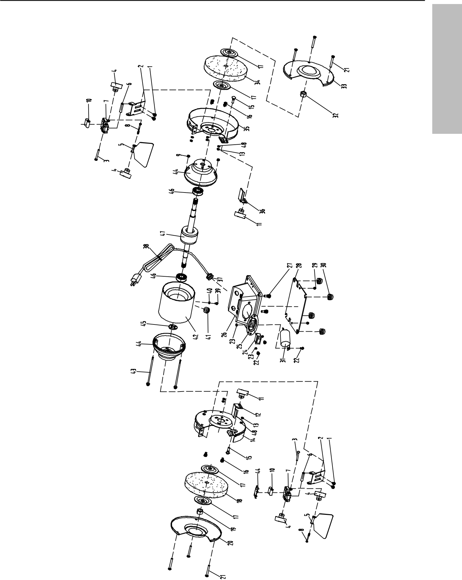

|  |
| --- |
| **Safety** |



|  |
| --- |
| **Setup** |

|  |
| --- |
| **Operation** |

|  |
| --- |
| **Maintenance** |

Item 57286 **For technical questions, please call 1-888-866-5797.** Page 15

**Limited 90 Day Warranty**

Harbor Freight Tools Co. makes every effort to assure that its products meet high quality and durability standards, and warrants to the original purchaser that this product is free from defects in materials and workmanship for the period of 90 days from the date of purchase. This warranty does not apply to damage due directly or indirectly, to misuse, abuse, negligence or accidents, repairs or alterations outside our facilities, criminal activity, improper installation, normal wear and tear, or to lack of maintenance. We shall in no event be liable for death, injuries

to persons or property, or for incidental, contingent, special or consequential damages arising from the use of our product. Some states do not allow the exclusion or limitation of incidental or consequential damages, so the above limitation of exclusion may not apply to you. THIS WARRANTY IS EXPRESSLY IN LIEU OF ALL OTHER WARRANTIES, EXPRESS OR IMPLIED, INCLUDING THE WARRANTIES OF MERCHANTABILITY AND FITNESS.

To take advantage of this warranty, the product or part must be returned to us with transportation charges prepaid. Proof of purchase date and an explanation of the complaint must accompany the merchandise. If our inspection verifies the defect, we will either repair or replace the product at our election or we may elect to refund the purchase price if we cannot readily and quickly provide you with a replacement. We will return repaired products at our expense, but if we determine there is no defect, or that the defect resulted from causes not within the scope of our warranty, then you must bear the cost of returning the product.

This warranty gives you specific legal rights and you may also have other rights which vary from state to state.



**26677 Agoura Road • Calabasas, CA 91302 • 1-888-866-5797**